Sri Lanka Institute of Information Technology

Lab Submission

04

**IT24102798**

**Sooriyabandara U.R.G.W.K.**

**Probability and Statistics | IT2120**

B.Sc. (Hons) in Information Technology

**Exercise**

1. Import the dataset (’Exercise.txt’) into R and store it in a data frame called “branch_data”.

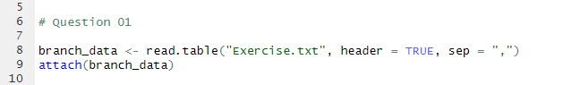

1. 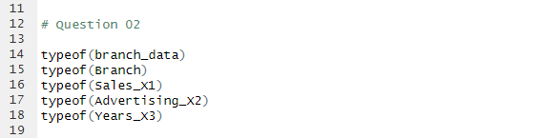Identify the variable type and scale of measurement for each variable.

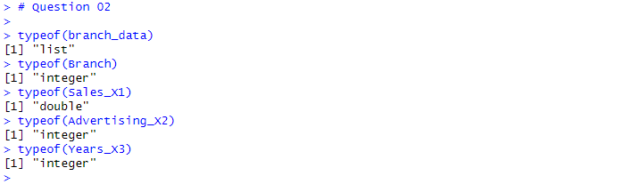

|  |  |  |
| --- | --- | --- |
| **Variable Name** | **Variable Type** | **Scale Of Measurement** |
| Branch | Integer | Nominal |
| Sales_X1 | Double | Ratio |
| Advertising_X2 | Integer | Ratio |
| Years_X3 | Integer | Ratio |

1. 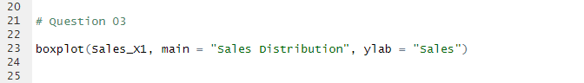Obtain boxplot for sales and interpret the shape of the sales distribution.

1. Calculate the five number summary and IQR for advertising variable.

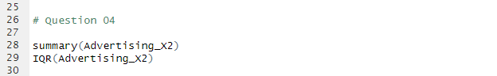

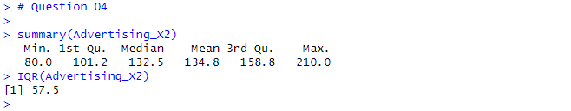

1. 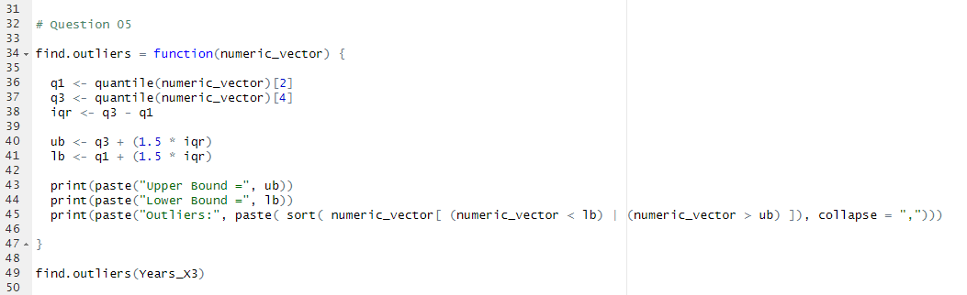Write an R function to find the outliers in a numeric vector and check for outliers in years variables.

